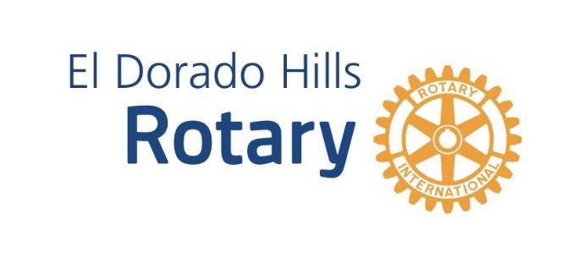
Media Release

EDH Rotary Wine at Town Center canceled for 2022

May 11, 2022

El Dorado Hills, CA. Effective today, The Rotary Club of El Dorado Hills Wine & Dine at Town Center has been canceled for 2022. The event is intended to highlight local wineries and restaurants. But the last few years have been especially hard on restaurants due to COVID-19, staffing, supply chain and the increased prices. Most of our generous past vendors are unable to participate in what would have been the 26th Annual event.

We want to thank the wineries, restaurants, and sponsors that agreed to participate this year. It was a big commitment to make in a difficult year.

The Club will begin evaluating what fundraising events might be held this year and next. Thanks to the continuing generosity of our community, sponsors, and attendees, EDH Rotary has helped thousands of people throughout the world. All profits from our events help support Rotary’s local and international projects and programs. Recent beneficiaries include:
- Bass Lake Park trail improvements
- The Upper Room, Placerville, to provide meals and services
- M.O.R.E. Rehab Center renovations
- Caldor Fire Victims
- EDCOE First 5 Christmas Baskets
- Local Student of the Month recognition
- ORHS & FLCC Scholarships
- ShelterBox USA Disaster Relief including Ukraine , Haiti, and Syria
- FOWAC Community Center in Northern Uganda

We value the long-term support of the El Dorado Hills area community, and hope to see you at future events.

Press contact: Claire Purtich, cpurtich@gmail.com

